Comparison of Classification Results using Classifier based on Indexing and Naive Bayes Classifier

Method I: Classifier Based on Indexing

1. Basic Algorithm
- Create Index
- Find most important word in an article
- Search in index
- Find the most recurring category
- Assign that category
- Check against actual category

- Steps 2 to 4 repeated on all articles in the last two files of dataset provided (article 20001 to 21578) to check the accuracy. Except:
- Those that do not have content: for the lack of a search word
- Those that do not have a category: no label to cross check with
- Articles chosen to be classified are removed from the data used to create Search Index and put in a separate file

2. Search Word Selection
- Filter Stop words
- Filter words less than length 3
- Perform Stemming
- Choose the most recurring string

3. Snapshot of Intermediate Output

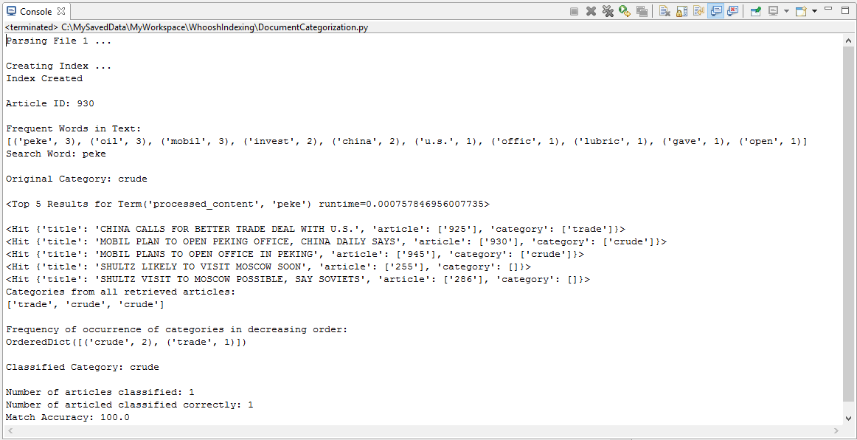

4. Snapshot of Final Output

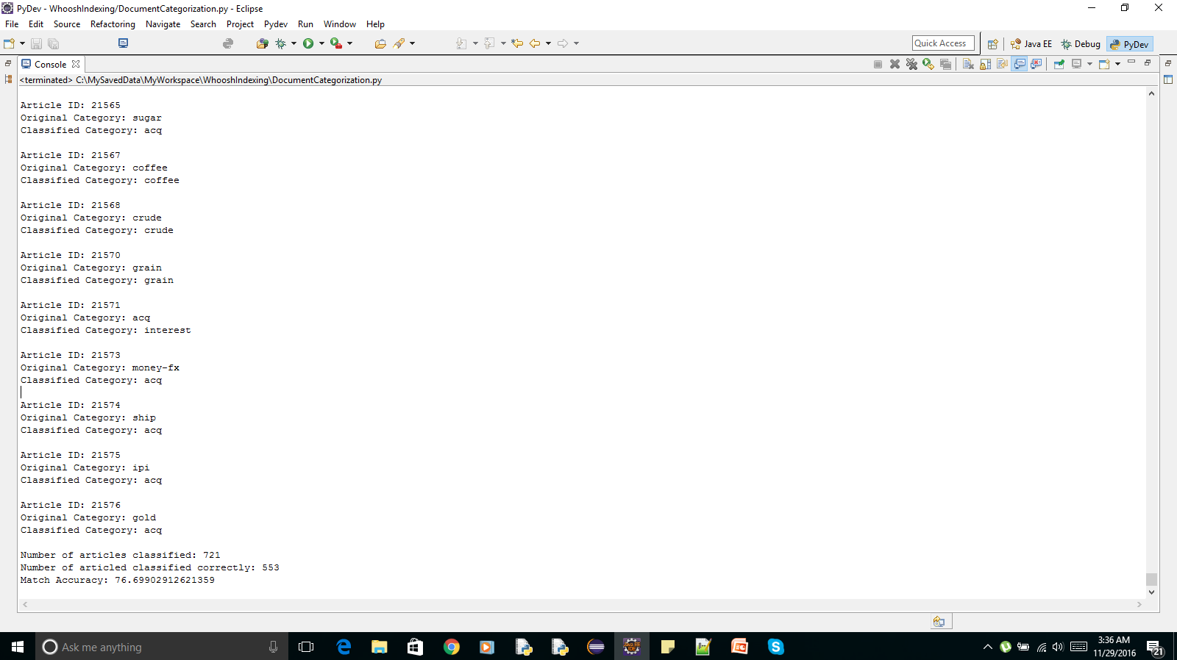
5. Implementation Code

import re, glob, os
from collections import Counter
from collections import OrderedDict
from whoosh.fields import Schema, STORED, TEXT, NUMERIC
from whoosh.qparser import QueryParser
from whoosh import index
from whoosh import scoring
from nltk import word_tokenize
from nltk.corpus import stopwords
from nltk.stem.snowball import SnowballStemmer

stopwords_list = stopwords.words()
p = re.compile('[a-zA-Z]+')
min_length=3
fileCount=0
item_count = 0
match_count = 0

#method to parse and extract information from an article
#Input: An article in XML format bound by the tags <REUTERS> and </REUTERS>
#Output: A list
#Elements of List
#0 - Article ID
#1 - Title
#2 - Body
#3 - Tokenized and Processed Body
#4 - Topic List
def parse_item(single_article):
#Extract Article Id
article_id = re.findall('NEWID="(.*?)">',item)

#Extract Title
title = re.findall('<TITLE>(.*?)</TITLE>',single_article)
if(len(title)>0):
title = str(title[0])
else:
title = ""

#Extract body
body = re.findall('<BODY>(.*?)/BODY>',single_article,re.DOTALL)
if (len(body)>0):
body = str(body[0]).replace("\n", " ")
else:
body = ""

#convert document content to a list of tokens
body_token = word_tokenize(body.lower())
#Create list of words after removing stop words and take only words with length>3
body_tokens = [SnowballStemmer("porter").stem(word) for word in body_token if word not in stopwords_list]
body_token_filtered = list(filter(lambda token: p.match(token) and len(token)>=min_length, body_tokens))

#Extract Categories
category = re.findall('<TOPICS>(.*?)</TOPICS>',item)
category = str(category[0])
categories_list = re.findall('<D>(.*?)</D>',category)

return_data = [article_id, title, body, body_token_filtered,categories_list]
return return_data

#Build Index
schema = Schema(articleId = NUMERIC(stored=True),
title = STORED,
category = STORED,
content = TEXT,
processed_content = TEXT)

if not os.path.exists("indexdir"):
os.mkdir("indexdir")

ix = index.create_in("indexdir",schema)

writer = ix.writer()

path = 'C:/NLP_Loveena/Doc_Classify - Method1/DataSetIndexing/*.sgm'
files=glob.glob(path)

for file in files:
fileCount += 1
print ("Parsing File " + str(fileCount) + " ...")

f = open(file)
text = f.read()
f.close()
#Extract all article in file
match = re.findall('<REUTERS.*?</REUTERS>',text, re.DOTALL)

for item in match:
#Call method to parse each article and extract required information
parsed_data = parse_item(item)

article_id = parsed_data[0]
title = parsed_data[1]
body = parsed_data[2]
processed_content = ' '.join(parsed_data[3])
categories = parsed_data[4]

#Write to Index
writer.add_document(articleId = article_id,
title = title,
category = categories,
content = body,
processed_content = processed_content)

print ("\nCreating Index ...")
writer.commit()
print ("Index Created\n")

#Read data to classify
path = 'C:/NLP_Loveena/Doc_Classify - Method1/DataSetIndexing/TestSet.txt'
with open(path) as f:
text = f.read()

#Extract all articles
match = re.findall('<REUTERS.*?</REUTERS>',text, re.DOTALL)

for item in match:
#Call method to parse each article and extract required information
parsed_data = parse_item(item)
if(parsed_data[3]==[] or parsed_data[4]==[]):
continue

item_count += 1

article_id = parsed_data[0]
print("Article ID: " + article_id[0])

freq_words = Counter(parsed_data[3]).most_common(10)
#Pick the most frequent word as the search word
search_word = freq_words[0][0]

original_category = parsed_data[4][0]
print("Original Category: " + original_category)

#Query the index for the search word to retrieve all articles that contain that word
qp = QueryParser("processed_content", schema=ix.schema)
q = qp.parse(search_word)

#Retrieve the topics of all the articles returned by the search
category_list = []
with ix.searcher(weighting=scoring.TF_IDF()) as searcher:
results = searcher.search(q, limit=None)
for index in range(0,len(results)):
category_list.append(results[index]['category'])

category_list = sum(category_list,[])
#Pick the most frequently occurring category
ordered_category_freq = OrderedDict(sorted(dict(Counter(category_list)).items(), key=lambda v:v[1], reverse=True))
for key in ordered_category_freq:
new_category = key
if(not(new_category is '')):
break

print("Classified Category: " + new_category + "\n")
#Keep track of articles classified correctly
if (original_category == new_category):
match_count += 1

print("Number of articles classified: " + str(item_count))
print("Number of articled classified correctly: " + str(match_count))
match_percentage = (match_count/item_count)*100
print("Match Accuracy: " + str(match_percentage))
Method II: Naive Bayes Classifier

1. Basic Algorithm
- Parse document
- Feature preprocessing
- Build feature set for training and testing
- Train the classifier using train set
- Check accuracy against test set

- Segregation to train set and test set done as per the dataset
- Tried a few random split values, but going by the dataset worked the best
- Ignored articles with empty content or empty labels

2. Feature Selection
- Bag of Words Approach
- Filter Stop words
- Filter words less than length 3
- Perform Stemming
- Choose the most frequent w words

Note:
Greater the value of w, higher the accuracy.
However, greater is the memory and time requirements

3. Snapshot of Output with 500 features

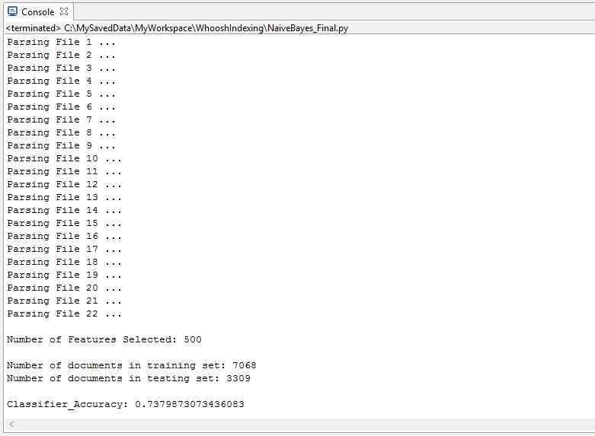

4. Snapshot of Output with 1000 features

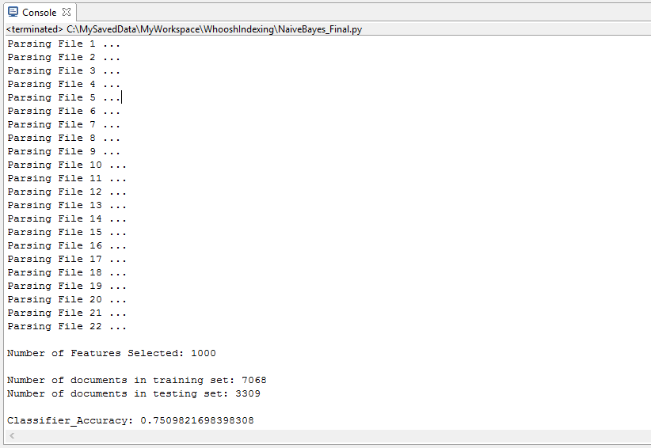
5. Implementation Code

import nltk, re, glob
from nltk import word_tokenize
from nltk.corpus import stopwords
from nltk.stem.snowball import SnowballStemmer

#list of all documents - content and category
document_list_train = []
document_list_test = []

#list of all words in dataset
all_words = []

#method to build feature set for each document
def document_features(document):
document_words = set(document)
features = {}
for word in word_features:
features['contains({})'.format(word)] = (word in document_words)
return features

path = 'C:/NLP_Loveena/Doc_Classify - Method2/DataSet/*.sgm'
files=glob.glob(path)
count=0;

#Iterate through each file
for file in files:
count += 1
print ("Parsing File " + str(count) + " ...")
f = open(file)
text = f.read()
f.close()

#Extract documents. 1000 per file. len(match)=1000
match = re.findall('<REUTERS.*?</REUTERS>',text, re.DOTALL)

#Iterate through each document in the this file
for item in match:

#Extract document id for each document
document_id = re.findall('NEWID="(.*?)">',item)

#Determine if it belongs to the train set or test set
doc_type = re.findall('LEWISSPLIT="(.*?)" CGISPLIT',item)
doc_type = str(doc_type[0])

#Extract title for each document
title = re.findall('<TITLE>(.*?)</TITLE>',item)
if(len(title)>0):
title = str(title[0])
else:
title = ""

#Extract content for each document. Ignore article if content is empty
body = re.findall('<BODY>(.*?)/BODY>',item,re.DOTALL)
if (len(body)>0):
body = str(body[0]).replace("\n", " ")
else:
continue

#convert document content to a list of tokens
body_token = word_tokenize(body.lower())
#Create list of words after removing stop words and take only words with length>3
stopwords_list = stopwords.words()
p = re.compile('[a-zA-Z]+');
min_length=3
body_tokens = [SnowballStemmer("porter").stem(word) for word in body_token if word not in stopwords_list]
body_token_filtered = list(filter(lambda token: p.match(token) and len(token)>=min_length, body_tokens))

#Create list of all words in corpus
all_words += body_token_filtered
#Extract topic for each document. Ignore article if topic is empty
categories_tags = re.findall('<TOPICS>(.*?)</TOPICS>',item)
if(len(categories_tags[0])==0):
continue
else:
categories = str(categories_tags[0])
categories_list = re.findall('<D>(.*?)</D>',categories)
category = categories_list[0]

#Create a tuple of words in document and category of document
document_tuple = (body_token_filtered, category)
#Add the document to it's corresponding list
if(doc_type=="TRAIN"):
document_list_train.append(document_tuple)
else:
document_list_test.append(document_tuple)

#Pick the most common x words in the dataset as features
x=1000
all_words_freq = nltk.FreqDist(all_words)
values = all_words_freq.most_common(x)
word_features = [list(t) for t in zip(*values)][0]
print("\nNumber of Features Selected: " + str(len(word_features)))

#train set and test set are lists where each element is a tuple of two things:
#one - the list of all features indicating if it is present or not in that document
#two - the category of the document
train_set = [(document_features(d), c) for (d,c) in document_list_train]
test_set = [(document_features(d), c) for (d,c) in document_list_test]

print("\nNumber of documents in training set: " + str(len(train_set)))
print("Number of documents in testing set: " + str(len(test_set)))

classifier = nltk.NaiveBayesClassifier.train(train_set)
classifier_accuracy = nltk.classify.accuracy(classifier, test_set)
print("\nClassifier_Accuracy: " + str(classifier_accuracy))

